**Union and union all in sql server - Part 17**

UNION and UNION ALL operators in SQL Server, are used to combine the result-set of two or more SELECT queries. Please consider India and UK customer tables below  
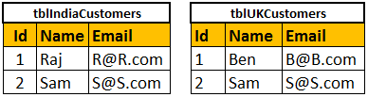  
  
  
  
  
  
  
  
  
**Combining the rows of tblIndiaCustomers and tblUKCustomers using UNION ALL**  
Select Id, Name, Email from tblIndiaCustomers  
UNION ALL  
Select Id, Name, Email from tblUKCustomers  
  
**Query Results of UNION ALL**  
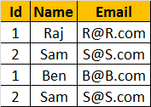  
  
  
**Combining the rows of tblIndiaCustomers and tblUKCustomers using UNION**  
Select Id, Name, Email from tblIndiaCustomers  
UNION  
Select Id, Name, Email from tblUKCustomers  
  
**Query Results of UNION**  
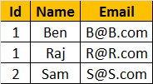  
  
  
**Differences between UNION and UNION ALL (Common Interview Question)**  
From the output, it is very clear that, **UNION removes duplicate** rows, where as **UNION ALL does not**. When use UNION, to remove the duplicate rows, sql server has to to do a distinct sort, which is time consuming. For this reason, UNION ALL is much faster than UNION.   
  
**Note:** If you want to see the cost of DISTINCT SORT, you can turn on the estimated query execution plan using CTRL + L.  
  
**Note:** For UNION and UNION ALL to work, the Number, Data types, and the order of the columns in the select statements should be same.  
  
**If you want to sort, the results of UNION or UNION ALL, the ORDER BY caluse should be used on the last SELECT statement as shown below.**  
Select Id, Name, Email from tblIndiaCustomers  
UNION ALL  
Select Id, Name, Email from tblUKCustomers  
UNION ALL  
Select Id, Name, Email from tblUSCustomers  
Order by Name  
  
**The following query, raises a syntax error**  
SELECT Id, Name, Email FROM tblIndiaCustomers  
ORDER BY Name  
UNION ALL  
SELECT Id, Name, Email FROM tblUKCustomers  
UNION ALL  
SELECT Id, Name, Email FROM tblUSCustomers  
  
**Difference between JOIN and UNION**  
**JOINS** and **UNIONS** are different things. However, this question is being asked very frequently now. UNION combines the result-set of two or more select queries into a single result-set which includes all the rows from all the queries in the union, where as JOINS, retrieve data from two or more tables based on logical relationships between the tables. In short, UNION combines rows from 2 or more tables, where JOINS combine columns from 2 or more table.